ROCA Volunteer Assignment
Batch 4 — Mobile Screen Specifications
My Serving Schedule · Swap Request
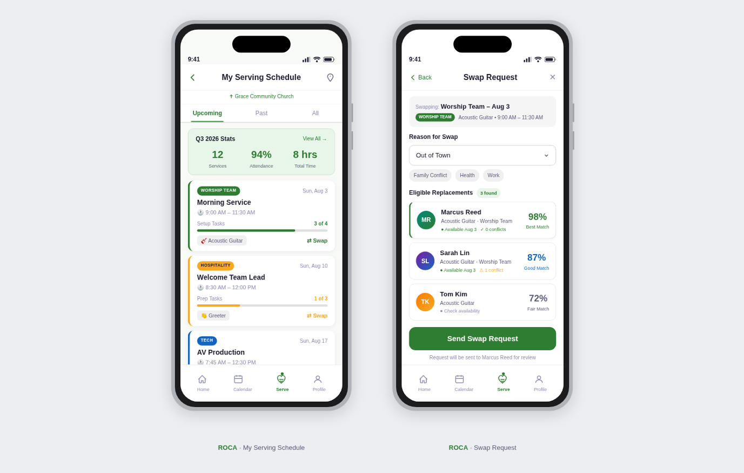
Figure 1 — ROCA Volunteer Assignment Mobile Screens (Batch 4): My Serving Schedule · Swap Request

Document | Value | Status
Version | v1.0 — Initial Release | DRAFT
Project | ROCA — Religious Organization Calendar App
Module | Volunteer Assignment Flow
Batch | Batch 4 (Screens 1–2)
Author | ROCA Design & Engineering Team
Date | 2025

Screen | Title | Primary Action
Screen 1 | My Serving Schedule | View quarterly stats / Request swap
Screen 2 | Swap Request | Select reason / Choose candidate / Send request

Design Principles: Mobile-first — 390×844 px (iPhone 15 Pro reference) | WCAG 2.1 AA contrast | Min 44 px tap targets | Green brand palette (#1A7A4A primary, #E8F5EE background) | Real-time data via REST + WebSocket

1.0 Document Overview
This specification document describes the two mobile screens that form ROCA Volunteer Assignment Batch 4. Screen 1 (My Serving Schedule) gives each volunteer a personalised dashboard showing their quarterly service statistics, a scrollable list of serving cards with progress indicators, and quick access to upcoming commitments. Screen 2 (Swap Request) enables volunteers to hand off a serving slot to an eligible peer by selecting a reason, browsing match-scored candidates, and dispatching the request with a single tap. Together these screens close the self-service loop introduced in earlier batches, empowering volunteers to manage their schedules without administrator intervention.
The document covers screen purpose, visual layout zones, user interaction patterns, data-binding specifications, and all backend API endpoints required to implement the two screens. All dimensions reference the 390×844 px iPhone 15 Pro frame; Android equivalents scale proportionally using density-independent units (dp/sp).

SCREEN 1 — MY SERVING SCHEDULE

1.1 Screen Purpose
The My Serving Schedule screen is the volunteer's personal command centre within the ROCA app. Launched from the main tab bar or a home-screen widget, it surfaces three key categories of information at a glance: aggregate performance statistics for the current quarter, a chronological list of serving engagements (past, active, and upcoming), and prominent entry points to related actions such as swapping slots and viewing event details. The screen is designed to motivate continued service by celebrating progress against quarterly targets while reducing the friction of schedule management.

1.2 Quarterly Stats Panel
A horizontally scrollable row of three metric cards sits directly beneath the navigation bar. Each card uses a large, bold numeral as the focal point and a short descriptor label beneath it. The three stats update in real-time from a single API call on screen load:
- Hours Served — accumulated volunteer hours for Q{current}; format H:MM; green progress ring encircles the figure
- Events Attended — count of confirmed-attended events; badge glows gold when target is reached
- Streak — consecutive weeks with at least one serving slot fulfilled; flame icon animates on screen entry

Metric Card | Value Example | Visual Treatment | Target Threshold
Hours Served | 47:30 | Green progress ring, large bold numeral | 60 h / quarter
Events Attended | 12 | Gold badge glow at target | 15 events / quarter
Streak | 5 weeks | Animated flame icon, orange accent | 8-week milestone badge

1.3 Serving Cards with Progress Indicators
Below the stats panel, a vertically scrollable list of serving cards represents each individual assignment. Cards are grouped into two collapsible sections: Upcoming (sorted chronologically) and Past (sorted reverse-chronologically). Each card contains the information a volunteer needs to prepare for or recall a serving slot:
- Event name and ministry badge (e.g., "Sunday Service — Worship Team") in the card header
- Date, time, and venue as a compact three-icon row beneath the header
- Role label (e.g., "Keyboard Player") in a teal pill chip
- Progress bar showing task completion (e.g., "3 of 5 tasks done") — connects to the task checklist from Batch 3
- Action tray: "View Details" (navigates to Assignment Detail) and "Swap" CTA (navigates to Screen 2)

Card State | Visual Style | Progress Bar | Available Actions
Upcoming | White card, green left-border accent (4 px) | Shows % complete; tappable to open tasks | View Details, Swap
Today | Light green fill #E8F5EE; pulsing dot beside date | Full-width bar, real-time update | View Details, Check In, Swap
Completed | Gray-tint card; checkmark badge top-right | Solid green 100% bar | View Details, Leave Feedback
Swapped Away | Strikethrough event name; swap icon overlay | Bar hidden; "Swapped" badge shown | View Details only

1.4 Layout Zones — My Serving Schedule
Zone | Component | Dimensions | Description
Z-01 | Navigation Bar | 390 × 52 px | Back arrow, "My Schedule" title (centered, 17 pt semibold), calendar icon (top-right); safe-area aware
Z-02 | Quarterly Stats Row | 390 × 110 px, scrollable | Three metric cards in horizontal HStack; 12 px gap; horizontal scroll overflows on small screens
Z-03 | Section Toggles | 390 × 44 px each | Two segmented toggle rows ("Upcoming" / "Past") with item-count badge; tap collapses / expands section
Z-04 | Serving Card List | 390 × auto, scrollable | VStack of cards (12 px gap); each card 390 × 120–145 px depending on action tray; full viewport scroll
Z-05 | Card Progress Bar | 346 × 6 px (within card) | Thin bar at bottom of card interior; green fill; "X/Y tasks" label right-aligned at 12 pt
Z-06 | Sticky Filter Bar | 390 × 44 px | Pill-chip filters: All, Worship, Ushers, Media, Kids; horizontally scrollable; sticky below nav bar on scroll
Z-07 | Empty State | Full viewport height | Centred illustration + "No upcoming serving slots" message + "Explore Opportunities" CTA if list is empty

1.5 Interactions — My Serving Schedule
Interaction | Trigger | Behaviour
View Details | Tap "View Details" on card | Push transition to Assignment Detail screen (Batch 3 Screen 2); passes assignmentId via route param
Initiate Swap | Tap "Swap" CTA on card | Push transition to Screen 2 (Swap Request); passes servingSlotId and eventId as route params
Check In | Tap "Check In" on today card | POST /serving-slots/{id}/check-in with GPS coordinates; updates card state to "In Progress"; haptic feedback
Filter by Ministry | Tap filter pill chip | Client-side filter; no API call; selected chip turns green; cards with non-matching ministry hidden with fade animation
Collapse Section | Tap section toggle row | Accordion collapse / expand with 250 ms ease-out; chevron rotates 180°; persists state in local storage
Stat Card Tap | Tap any stat card (Z-02) | Navigates to detailed history screen (Serving History); GET /volunteers/me/stats?period=quarter
Pull to Refresh | Pull down on list | Re-fetches /serving-slots and /stats; spinner shown during fetch; snackbar on error
Swipe to Swap | Swipe card left | Reveals red "Swap" action strip behind card; release past 60% threshold navigates to Swap Request screen

1.6 API Endpoints — My Serving Schedule
Scr | Method | Endpoint | Auth | Description
1 | GET | /volunteers/me/serving-slots | JWT | All serving slots for authenticated volunteer; supports ?status=upcoming|past|today&ministry=string
1 | GET | /volunteers/me/stats | JWT | Quarterly stats: hours_served, events_attended, streak_weeks; supports ?period=quarter|year
1 | POST | /serving-slots/{id}/check-in | JWT | Check-in with body { latitude, longitude }; validates proximity ≤ 200 m; returns updated slot state
1 | GET | /serving-slots/{id}/tasks | JWT | Task list for the card progress bar; returns {completed, total}; WebSocket channel available for live updates
1 | GET | /volunteers/me/ministries | JWT | List of ministry names for filter pill generation; cached 24 h client-side

SCREEN 2 — SWAP REQUEST

2.1 Screen Purpose
The Swap Request screen allows a volunteer to delegate one of their upcoming serving slots to a compatible peer. It is reached by tapping "Swap" on any Upcoming serving card in Screen 1, or by swiping the card left. The screen guides the volunteer through three steps: (1) selecting a reason for the swap, (2) choosing a candidate from a ranked shortlist of eligible volunteers, and (3) dispatching the formal request with an optional personal note. A match-score algorithm ensures that only volunteers with the right skills, availability, and ministry membership are surfaced, minimising wasted notifications and maximising acceptance rates.

2.2 Reason Selector
The reason selector is a segmented list of radio-style option rows at the top of the screen, beneath a compact event-context card that reminds the user which slot they are swapping. Selecting a reason is mandatory before the candidate list becomes interactive; this ensures the receiving volunteer receives adequate context.

Reason Code | Display Label | System Behaviour
CONFLICT | Schedule Conflict | Candidate list filters to volunteers free on the same date/time
ILLNESS | Illness / Health Issue | Urgency flag set on the swap request; candidates notified with higher push priority
TRAVEL | Travel / Away | Standard priority; swap request note pre-filled with "I will be travelling"
FAMILY | Family Emergency | Urgency flag set; admin notified in addition to candidate
WORKLOAD | Work Commitment | Standard priority; match score unchanged
OTHER | Other (please specify) | Reveals free-text input field below the list (max 200 chars)

2.3 Eligible Candidates with Match Scores
Below the reason selector, a scrollable list shows candidates ranked by a composite match score (0–100). Each candidate row is a horizontal card containing:
- Avatar (40 px circle) with online/offline status dot
- Full name (16 pt semibold) + ministry membership badge
- Match score prominently displayed as a filled arc gauge with numeric label (e.g., "94 / 100")
- Score breakdown tooltip (long-press): skill alignment, availability, past-acceptance rate, proximity score
- Availability indicator: green "Available" chip or amber "Likely Available" chip
- Past-serving-together count: "Served together 3×" in gray caption

Match Score Breakdown
Factor | Weight | Max Points | Calculation Basis
Skill Alignment | 35% | 35 | Overlap between candidate skill tags and event role requirements
Availability Overlap | 30% | 30 | Calendar availability vs. event date/time; sourced from availability preferences
Past Acceptance Rate | 20% | 20 | Historical swap acceptance rate for this candidate in last 12 months
Proximity / Zone | 10% | 10 | Distance between candidate home zone and event venue
Relationship Score | 5% | 5 | Times the requester and candidate have served together in the past

2.4 Send Button and Request Confirmation Flow
Once a reason is selected and a candidate is highlighted, the "Send Swap Request" button at the bottom becomes active (green #1A7A4A, full-width, 52 px height). An optional "Add a Personal Note" text field sits directly above the button. The send flow follows these steps:
- Requester taps "Send Swap Request" — haptic impact feedback fires immediately
- Loading spinner replaces button label while POST /swap-requests is in flight
- On success: screen transitions to a compact confirmation sheet (bottom sheet, 320 px) showing "Request Sent!" with candidate avatar and expected response time
- Candidate receives push notification: "You have a swap request from [Name] for [Event]"
- On error: button reverts; inline error toast shown; no navigation change

2.5 Layout Zones — Swap Request
Zone | Component | Dimensions | Description
Z-01 | Navigation Bar | 390 × 52 px | Back arrow (dismisses screen), "Swap Request" title (centered), help icon (right)
Z-02 | Event Context Card | 390 × 72 px | Compact card: ministry badge, event name (semibold), date & time & role in caption row; non-interactive; anchored top
Z-03 | Reason Selector | 390 × auto (6–7 rows) | Labelled section "Why are you swapping?"; 6 radio-row options + optional text field for OTHER; single-select
Z-04 | Candidate List | 390 × auto, scrollable | Scrollable list under "Eligible Volunteers" heading; each card 390 × 84 px; sorted by match score DESC
Z-05 | Match Score Arc | 56 × 56 px (within card) | Circular progress arc (SVG); green fill for score ≥75; amber for 50–74; red for <50; numeric label inside
Z-06 | Note Input Field | 390 × 80 px | Expandable textarea; hint text "Add a personal note (optional)"; 200-char limit with live counter
Z-07 | Send CTA Bar | 390 × 80 px, sticky | Sticky bottom bar; "Send Swap Request" full-width green button; disabled until reason + candidate selected

2.6 Interactions — Swap Request
Interaction | Trigger | Behaviour
Select Reason | Tap reason row | Row highlighted green; radio icon filled; candidate list becomes interactive; "OTHER" reveals text input
Select Candidate | Tap candidate row | Row gets green border; avatar ring highlighted; "Send" button activates; previously selected row deselects
View Match Details | Long-press candidate card | Bottom sheet slides up with score breakdown: skill %, availability %, acceptance rate, past service count
Send Request | Tap "Send Swap Request" CTA | POST /swap-requests; loading state; success bottom sheet; candidate push notification dispatched
Edit Note | Tap note field (Z-06) | Keyboard rises; view scrolls up to keep note field visible; 200-char counter shown
Dismiss | Back arrow or swipe down | If reason selected, confirmation dialog: "Discard swap request?"; if nothing selected, dismisses immediately
Sort Candidates | Tap sort icon (top-right of Z-04) | Bottom sheet: sort options — Match Score (default), Name A–Z, Availability, Past service together
Empty State | No eligible candidates returned | Illustration + "No eligible volunteers found" + "Contact your team leader" button in candidate list area

2.7 API Endpoints — Swap Request
Scr | Method | Endpoint | Auth | Description
2 | GET | /serving-slots/{id}/swap-candidates | JWT | Returns ranked list of eligible candidates with match scores; accepts ?reason=CONFLICT|ILLNESS|...
2 | POST | /swap-requests | JWT | Create swap request: body { servingSlotId, candidateVolunteerId, reason, note }; returns swapRequestId
2 | GET | /volunteers/{id}/availability | JWT | Candidate availability windows for tooltip and availability chip; returns array of {date, available: bool}
2 | GET | /swap-candidates/{id}/score-breakdown | JWT | Detailed match score breakdown for long-press tooltip: {skill, availability, acceptance, proximity, relationship}
2 | DELETE | /swap-requests/{id} | JWT | Cancel a pending swap request (requester only); triggers cancellation push to candidate

3.0 Technical Reference & Appendix

3.1 Complete API Summary
All API calls use HTTPS with Bearer JWT authentication. Base URL: https://api.roca.app/v1. All responses follow the ROCA standard envelope format { data: ..., meta: {...}, errors: [...] }.

Scr | Method | Endpoint | Auth | Purpose
1 | GET | /volunteers/me/serving-slots | JWT | All serving slots (upcoming, today, past)
1 | GET | /volunteers/me/stats | JWT | Quarterly stats: hours, events, streak
1 | POST | /serving-slots/{id}/check-in | JWT | GPS check-in for today's serving slot
1 | GET | /serving-slots/{id}/tasks | JWT | Task progress data for card progress bar
1 | GET | /volunteers/me/ministries | JWT | Ministry list for filter pill generation
2 | GET | /serving-slots/{id}/swap-candidates | JWT | Ranked eligible volunteers with match scores
2 | POST | /swap-requests | JWT | Create swap request with reason + note + candidate
2 | GET | /volunteers/{id}/availability | JWT | Candidate availability windows
2 | GET | /swap-candidates/{id}/score-breakdown | JWT | Detailed score breakdown for tooltip
2 | DELETE | /swap-requests/{id} | JWT | Cancel pending swap request

3.2 Navigation Flow Diagram
The two screens form a swap request funnel with three possible outcomes:
My Serving Schedule (Screen 1)
↓ Tap "Swap" on any Upcoming card
Swap Request (Screen 2)
↓ Select reason + candidate + send
Outcomes: [1] Request Sent → Confirmation Sheet | [2] Cancel → Back to Schedule | [3] No candidates → Contact Team Leader

3.3 Design Tokens Reference
Token Name | Value | Usage
color.brand.primary | #1A7A4A | Primary buttons, active states, section headings, progress bar fill, send CTA
color.brand.primaryLight | #E8F5EE | Card backgrounds (today state), info box fills, reason selector hover
color.brand.accent | #34C97A | Progress bar gradient end, score arc fill ≥75, streak flame accent
color.score.high | #1A7A4A | Match score arc ≥75 (green)
color.score.medium | #E07B20 | Match score arc 50–74 (amber)
color.score.low | #D32F2F | Match score arc <50 (red)
color.status.today | #1A7A4A + pulsing dot | Today serving card border and dot animation
spacing.base | 8 px | Base spacing unit; all margins/paddings are multiples of 8
radius.card | 12 px | Serving card and candidate row corner radius
font.size.heading | 24 pt | Screen section headings
font.size.body | 15 pt | Card labels, detail rows, reason options

3.4 Accessibility Checklist
Requirement | Implementation | Screen(s)
Min touch target 44×44 px | All buttons, cards and radio rows padded to minimum target | Both
WCAG AA contrast 4.5:1 | Green #1A7A4A on white = 7.2:1; tested in Figma Contrast plugin | Both
Screen reader labels | accessibilityLabel on all icon buttons, avatars, progress bars, and arcs | Both
Progress bar ARIA | role="progressbar", aria-valuenow, aria-valuemin=0, aria-valuemax applied | Screen 1 (card bars)
Dynamic type support | All text in scalable sp/em units; card layout reflows at 200% text size | Both
Reduced-motion | Pulse animation, flame animation, score arc animation disabled if prefers-reduced-motion | Both
Keyboard / D-pad nav | Tab order: nav bar → stats row → filter chips → card list; swap screen: reason → candidates → note → send | Both
Error announcements | API errors announced via accessibilityAlert (iOS) / LiveRegion.ASSERTIVE (Android) | Screen 2 send flow

3.5 Revision History
v1.0 (2025) — Initial Batch 4 specification: Screen 1 (My Serving Schedule) and Screen 2 (Swap Request) defined
Pending v1.1 — Add swap request cancellation flow from Screen 1 card (after request sent)
Pending v1.2 — Add admin swap approval view: override, approve, or reassign pending requests
Pending v1.3 — Add recurring-swap preference setting for volunteers who frequently swap the same slot

